This second DNS capture shows a complete, clean, textbook example of how a device resolves a domain using Google Public DNS, including both A and HTTPS record queries.
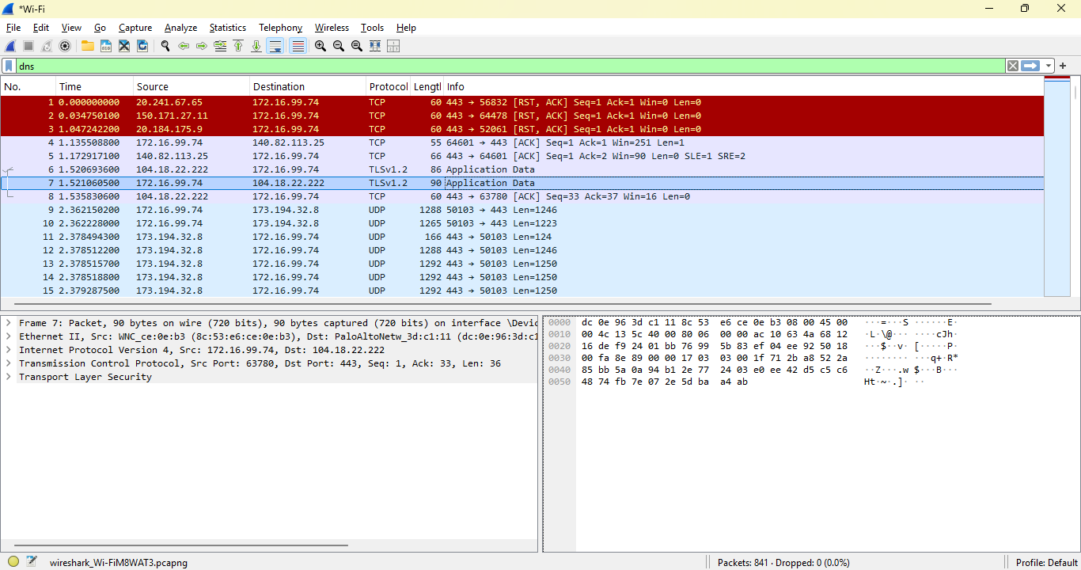
This capture shows my device (172.16.**.**) performing DNS lookups for dns.google using Google’s public DNS servers (8.8.8.8 and 8.8.4.4). The queries include both A records and HTTPS records, indicating that the system is checking for encrypted DNS-over-HTTPS capabilities. The responses return Google’s public DNS IPs, which is normal behavior. This capture demonstrates modern DNS resolution patterns, including service metadata queries used by browsers and operating systems to determine support for encrypted DNS.
The important takeaway:
This device (172.16.**.**) is performing DNS lookups for dns.google, using Google’s public DNS servers (8.8.8.8 and 8.8.4.4). It requests both A records (IPv4 addresses) and HTTPS records, which are part of modern encrypted DNS and service metadata.
This is normal, modern DNS behavior.
The capture shows (packet-by-packet)
✔ 1. My device is querying Google DNS
Source: 172.16.**.** Destination: 8.8.8.8 and 8.8.4.4 Protocol: DNS (UDP)

This means my device is using Google Public DNS instead of:
- Your router
- Your ISP
- A local DNS resolver
This is common when:
- A browser (Chrome, Edge) forces Google DNS
- A VPN overrides DNS
- A system uses encrypted DNS fallback
- A user manually configures Google DNS
✔ 2. You captured A record queries
Example:
Code
Standard query 0x62a0 A dns.google
This means:
“Give me the IPv4 address for dns.google.”
The response:
Code
A 8.8.8.8
A 8.8.4.4
This is Google returning its own public DNS server IPs.
✔ 3. You captured HTTPS record queries
Example:
Code
Standard query 0x2a52 HTTPS dns.google
This is the deeper part — and it’s important.

An HTTPS DNS record is a modern DNS type used for:
- Encrypted DNS (DoH)
- Service metadata
- Load balancing
- Endpoint discovery
- Performance optimization
It can contain:
- ALPN (protocol negotiation)
- DoH endpoint URLs
- Priority values
- SVCB (Service Binding) data
This is part of the new DNS standard (RFC 8484, RFC 9460).
The device is checking:
“Does dns.google support HTTPS-based DNS resolution?”
This is exactly what Chrome, Edge, and Android do.
✔ 4. The responses show Google returning multiple IPs
Example:
Code
A 8.8.8.8
A 8.8.4.4
This is:
- Load balancing
- Redundancy
- Geo-distribution
Google DNS always returns both.
What this says about my system’s behavior
✔My device is using Google DNS
This is not default for many networks. It means:
- A browser or OS setting is overriding DNS
- Possibly encrypted DNS is enabled
- Possibly a VPN or security tool is active
✔ My device is checking HTTPS DNS capability
This is modern behavior:
- Chrome
- Edge
- Android
- Windows 11
All perform HTTPS record lookups to determine:
“Should I upgrade DNS to encrypted DNS-over-HTTPS?”
✔ My device is performing normal DNS resolution
There is nothing suspicious here.
Deep-dive: Why HTTPS DNS records matter
Modern DNS is evolving:
- A / AAAA records → traditional IP lookups
- HTTPS / SVCB records → modern service discovery
HTTPS records allow:
- DNS-over-HTTPS (DoH)
- DNS-over-TLS (DoT)
- Load balancing
- Endpoint selection
- Protocol negotiation
The screen capture shows my device participating in this modern DNS ecosystem.

